Experiment 40

NATURAL LANGUAGE PROCESSING

AIM: To study and understand the formal design, specification and modelling of Natural Language Processing using Automata Theory

NATURAL LANGUAGE PROCESSING (NLP) :

Natural language processing is a field of linguistics and computer science which focuses on processing natural language. Natural languages are human spoken languages like English, Telugu and Tamil, in opposition to artificial languages such computer languages C or Java. The main goal of NLP is to make human languages automatically processable. It implies finding techniques to convert an utterance which can be either spoken or written into formal data. Formal data are a representation of that utterance that can be processed using a computer and with no or minimal supervision. Some part of natural language processing relies on automata theory.

FINITE AUTOMATA FOR SIMPLE STRUCTURES :

Automata for Recognizing Dates :

Suppose we want to recognize dates (just day and month pairs) written in the format day/month. The day and the month may be expressed as one or two digits (e.g. 11/2, 1/12 etc.). This format corresponds to the following simple FSA, where each character corresponds to one transition:

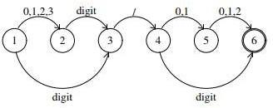

This is a NFA. For example, an input starting with the digit 3 will move the FSA to both state 2 and state 3.

Suppose we want to recognize a comma-separated list of such dates, the FSA can be designed as shown below. It has a cycle and can accept a sequence of indefinite length.

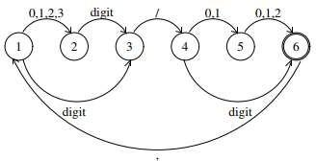
Lexicon :

In linguistics, a lexicon is the vocabulary of a person, group or language. It contains all the minimal grammatical elements of a language. Sample lexicon for the word do and some of its derivatives is shown below:
do did does done
Efficient representation of lexicons are possible using finite state automata as shown below.

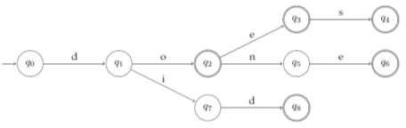

Constructing a Deterministic Finite Automata can improve the access and minimizing the automata can reduce the number of states considerably.

Can Finite Automata model the syntax of natural languages?

The syntax of natural languages cannot be described by Finite Automata. Strings having infinite recursion cannot be generated by a FSM. However, FSMs are very useful for partial grammars which don’t require full recursion. For representing complex structures, context free grammars are useful.
CONTEXT FREE GRAMMARS :

In formal language theory, context-free grammar (CFG) is a certain type of formal grammar. A set of production rules that describe all possible strings in a given formal language. Languages generated by context-free grammars are known as context-free languages.

CFGs arise in linguistics where they are used to describe the structure of sentences and words in a natural language, and they were in fact invented by the linguist Noam Chomsky for this purpose.

In computer science, as the use of recursively-defined concepts increased, they are used more and more. In an early application, grammars are used to describe the structure of programming languages. In a newer application, they are used in an essential part of the Extensible Markup Language (XML) called the Document Type Definition.

A CFG has four components:
- A set of non-terminals
- A set of terminals
- A set of rules (productions)
- A start symbol
A Simple CFG for a fragment of English S -> NP VP
VP -> VP PP
VP -> V
VP -> V NP VP -> V VP NP -> NP PP PP -> P NP
;;; lexicon V -> can V -> fish NP -> fish
NP -> rivers NP -> pools
NP -> December NP -> Scotland NP -> it
NP -> they P -> in
The rules with terminal symbols on the RHS correspond to the lexicon. Here are some strings which the grammar generates, along with their bracketings:

they fish
(S (NP they) (VP (V fish)))

they can fish
(S (NP they) (VP (V can) (VP (V fish))))

they fish in rivers
(S (NP they) (VP (VP (V fish)) (PP (P in) (NP rivers))))

they fish in rivers in December
(S (NP they) (VP (VP (V fish)) (PP (P in) (NP (NP rivers) (PP (P in) (NP December))))))

Parse Tree

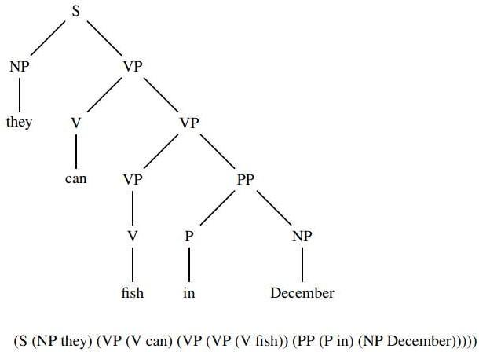
A CFG only defines a language. It does not say how to determine whether a given string belongs to the language it defines. To do this, a parser can be used whose task is to map a string of words to its parse tree. A parse tree or derivation tree is an ordered, rooted tree that represents the syntactic structure of a string according to some context-free grammar.

RESULT:

The application of finite automata and Context Free Grammars in the field of natural language processing is studied.

